Batch: D2 Roll No.: 25

Experiment / assignment / tutorial No. 2

Grade: AA / AB / BB / BC / CC / CD /DD

Signature of the Staff In-charge with date

TITLE: Write a program to accept 3 numbers from the user and find the largest of the 3 numbers using
If - else if-else
Ternary operator

AIM: Write a program to accept 3 numbers from the user and find the largest of the 3 numbers using
If - else if-else
Ternary operator
______________________________________________________________________
Expected OUTCOME of Experiment:

A error-less output which displays what program is all about and expects the requirements of the user.
The result of getting the largest number among the three numbers entered by user using if-else and ternary operator is the main purpose of this experiment.

_____________________________________________________________________
Books/ Journals/ Websites referred:

- Programming in C, second edition, Pradeep Dey and Manas Ghosh, Oxford University Press.
- Programming in ANSI C, fifth edition, E Balagurusamy, Tata McGraw Hill.
- Introduction to programming and problem solving , G. Michael Schneider ,Wiley India edition.
- http://cse.iitkgp.ac.in/~rkumar/pds-vlab/

_____________________________________________________________________
Problem Definition:

Ask user to input three numbers. Compare three numbers to find the largest of them using
- Nested if else statement
- Using ternary operator

Flowchart:
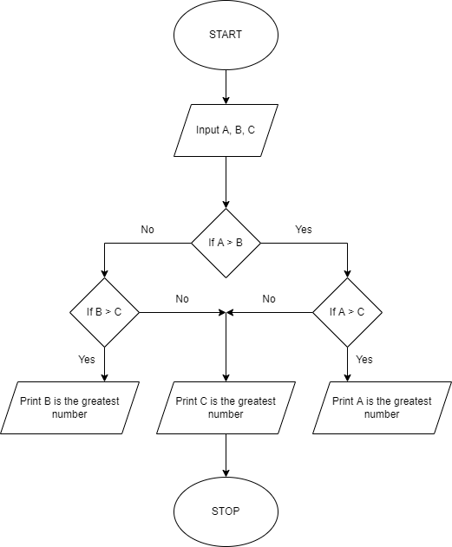
Largest number using if-else statement
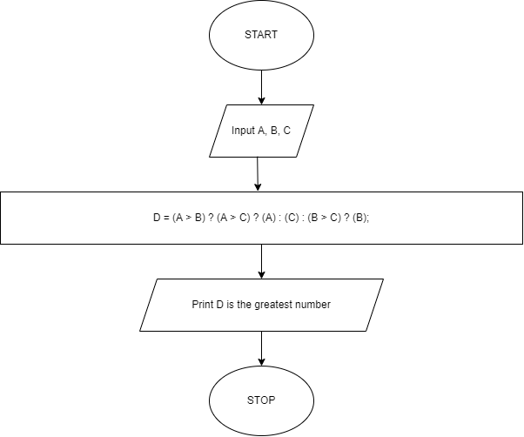
Largest Number using Ternary Operator
Output(s):

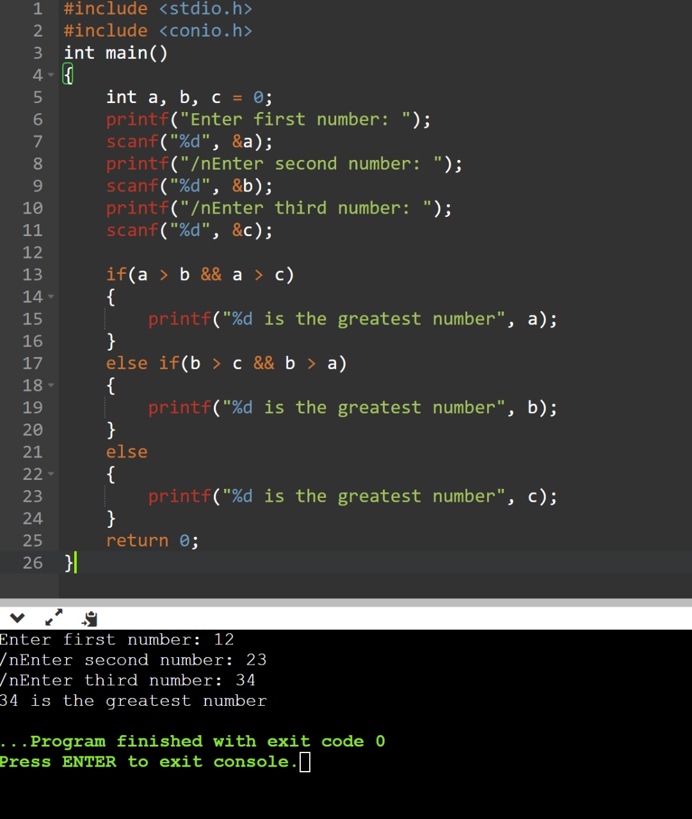
Using if-else statement

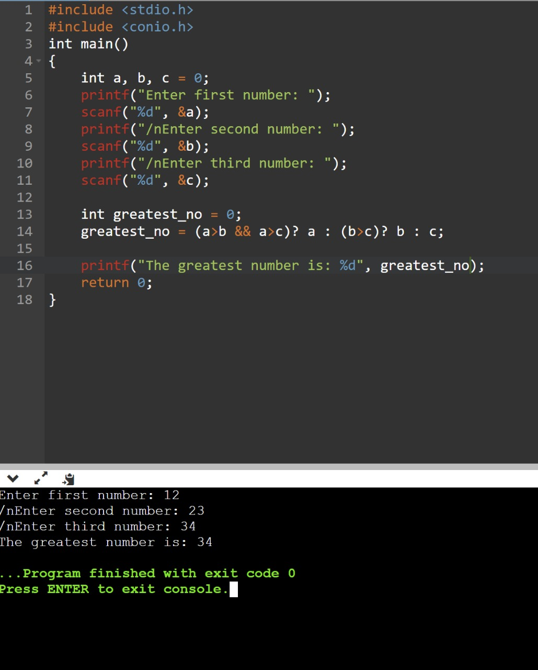
Using ternary operator

Conclusion:

Therefore I conclude that the program of finding the largest number can be written using if-else statement and without if-else statement using the ternary operator.

Post Lab Descriptive Questions

- Write a code snippet to perform left shifting of bits by some positions
Answer:

In arithmetic-logic unit (which is within the CPU), mathematical operations
like: addition, subtraction, multiplication and division are done in bit-level.
To perform bit-level operations in C programming, bitwise operators are
used.
BITWISE AND Operator &

K. J. Somaiya College of Engineering, Mumbai-77
(A Constituent College of Somaiya Vidyavihar University)

Department of Science and Humanities

The output of bitwise AND is 1 if the corresponding bits of two operands is
1. If either bit of an operand is 0, the result of corresponding bit is
evaluated to 0.
Example: 12 & 25 = (01100) & (11001) = (01000) = 8

BITWISE OR Operator
The output of bitwise OR is 1 if at least one corresponding bit of two
operands is 1.
In C Programming, bitwise OR operator is denoted by |.
Example: 4 | 2 = (100) | (010) = (110) = 6
BITWISE XOR Operator ^
The result of bitwise XOR operator is 1 if the corresponding bits of two
operands are opposite. It is denoted by ^.
Example: 12 ^ 25 = (01100) ^ (11001) = (10101) = 21
RIGHT SHIFT Operator >>
Right shift operator shifts all bits towards right by certain number of
specified bits. It is denoted by >>.
Example: 212 = (11010100)
212>>2 = (00110101)
LEFT SHIFT Operator <<
Left shift operator shifts all bits towards left by a certain number of
specified bits. The bit positions that have been vacated
by the left shift operator are filled with 0. The symbol of the left shift operator
is <<. Example: 212 = (11010100)
212<<1 = (110101000)

- Write associative rules and precedence table of various operators.
Answer:
#include <stdio.h>
int main()
{
int num = 212;
int i;
for (i=0; i<=2; ++i)
printf("Right shift by %d: %d\n", i, num>>i);
printf("\n");
for (i=0; i<=2; ++i)
printf("Left shift by %d: %d\n", i, num<<i);
return 0;
}

3. Write associative rules and precedence table of various operators.
Ans: The precedence of operators determines which operator is executed first if
there is more than one operator in an expression.

Date: _____________ Signature of faculty in-charge

